भारत मौसम विज्ञान विभाग |  | India Meteorological Department
Thursday 07th May 2026 (17th Vaisakha 1948 Saka)
Summary of observations recorded at 0830 hours IST: The Western Disturbance as a trough in westerlies lay as a cyclonic circulation over northwest Uttar Pradesh and adjoining Uttarakhand between 5.8 and 7.6 km above m. s. l. at 0530 hrs IST of today l. It persisted over the same region. However, the trough in westerlies between 3.1 & 7.6 km above m. s. l. roughly along Long. 80°E to the north of Lat. 25°N moved away at 0530 hrs IST of today. The upper air cyclonic circulation over northeast Uttar Pradesh & neighbourhood lay over east Bihar at 0530 hrs IST of today. It persisted over the same region and extended between 1.5 & 4.5 km above m. s. l. The upper air cyclonic circulation over central Assam & neighbourhood persisted and extended upto 1.5 km above m. s. l. An upper air cyclonic circulation lay over Central Parts of South Madhya Pradesh & neighbourhood at 1.5 km above m. s. l. An upper air cyclonic circulation lay over central Pakistan & adjoining south Punjab and extended upto 1.5 km above m. s. l. at 0530 hrs IST of today. It persisted over the same region. An upper air cyclonic circulation lay over southeast Arabian Sea and adjoining Lakshadweep off south Kerala coast at 0.9 km above m. s. l. at 0530 hrs IST of today. It persisted over the same region and extended upto 1.5 km above m. s. l. A trough/Wind discontinuity ran from southwest Madhya Pradesh to cyclonic circulation over southeast Arabian Sea and adjoining Lakshadweep off south Kerela across Madhya Maharashtra, Interior Karnataka & Kerala at 0530 hrs IST of today. It ran from cyclonic circulation over southeast Arabian Sea and adjoining Lakshadweep off south Kerela to southwest Madhya Pradesh across Interior Karnataka and Maharashtra at 0.9 km above m. s. l. A trough ran from central parts of south Madhya Pradesh to Jharkhand across Chhattisgarh at 0.9 km above m. s. l. at 0530 hrs IST of today. It persisted over the same region. An upper air cyclonic circulation lay over north Haryana & neighbourhood at 1.5 km above m. s. l. at 0530 hrs IST of today. It persisted over the same region. An upper air cyclonic circulation lay over interior Odisha and adjoining Chhattisgarh at 1.5 km above m. s. l. at 0530 hrs IST of today. It persisted over the same region. The north-south trough / Wind discontinuity from North Interior Karnataka to Gulf of Mannar across Rayalaseema and Tamil Nadu became less marked at 0530 hrs IST of today. The upper air cyclonic circulation over north Telangana & neighbourhood became less marked at 0530 hrs IST of today. The upper air cyclonic circulation over southwest Rajasthan became less marked at 0530 hrs IST of today. The upper air cyclonic circulation over Gulf of Mannar & neighbourhood became less marked at 0530 hrs IST of today. A fresh western disturbance is likely to affect Western Himalayan Region from 10th May, 2026.

Maximum Temperature Departures (as on 06-05-2026):Maximum temperatures were appreciably above normal (3.1°C to 5.0°C) at a few places over Kerala & Mahe; at isolated places over Assam & Meghalaya; above normal (1.6°C to 3.0°C) at many places over Lakshadweep; at a few places over Andaman & Nicobar Islands, Coastal Karnataka; at isolated places over Jammu & Kashmir, Konkan & Goa, Nagaland, Manipur, Mizoram & Tripura, Odisha, Saurashtra & Kutch, Tamil Nadu, Puducherry & Karaikal; markedly below normal (-5.1°C or less) at a few places over East Uttar Pradesh, Haryana-Chandigarh-Delhi, Uttarakhand, West Uttar Pradesh; at isolated places over Assam & Meghalaya, Bihar, Chhattisgarh, East Madhya Pradesh, Himachal Pradesh, Jharkhand, Odisha, West Madhya Pradesh; appreciably below normal (-3.1°C to -5.0°C) at a few places over East Rajasthan, Punjab; at isolated places over Andaman & Nicobar Islands, Coastal Andhra Pradesh & Yanam, Gangetic West Bengal, Jammu & Kashmir, Sub-Himalayan West Bengal & Sikkim, Telangana, Vidarbha, West Rajasthan; below normal (-3.0°C to -1.6°C) at a few places over Rayalaseema; at isolated places over Gujarat Region, Nagaland, Manipur, Mizoram & Tripura, Saurashtra & Kutch, Tamil Nadu, Puducherry & Karaikal and these were near normal over rest parts of the country. The highest maximum temperature of 42.9°C was reported at Rajkot (A) (Gujarat).
Preliminary Earthquake Report: An earthquake shock of Slight intensity at its origin with epicenter at Lat. 29.744° North and Long. 70.273°East, 352 km above m. s. l. WNW of Bikaner; Rajasthan; India, Pakistan about 1299 kms away from Pune, was recorded by the seismographs in the meteorological Office Pune at 09 Hrs. 37 Min. 50 Secs. IST on 06-05-2026 having its magnitude 4.9 on the Richter scale.

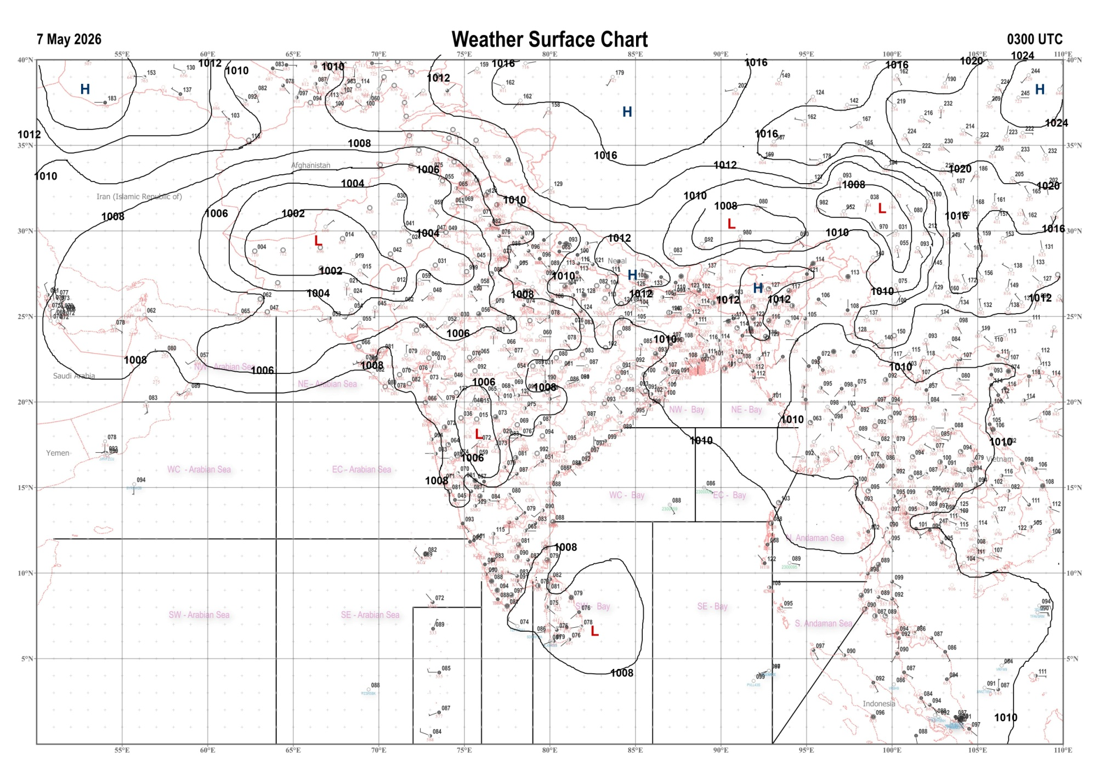 | 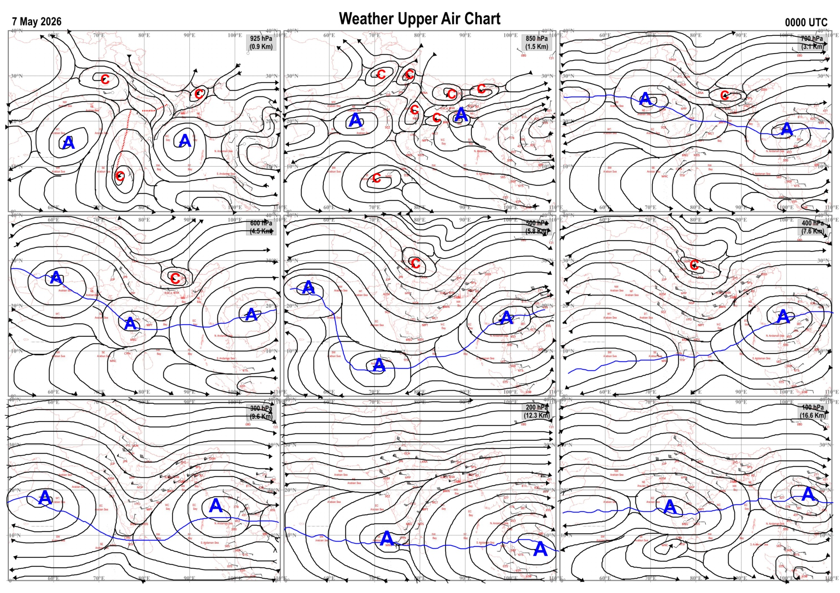
Fig.1. Analysed surface chart based on 03z observation | Fig.2. Analysed upper air chart based on 00z observation
V.K.Shripad
Scientific Officer ‘I’
CR & S Office, Pune  Issued at 1245 hrs. IST |  | Weather Forecasting Division  CR&S, Pune

Indian regions | Realised rainfall (chief amount in cm during past 24 hrs):
East | many places: Arunachal Pradesh, Nagaland-Manipur-Mizoram-Tripura and Bihar  a few places: Assam & Meghalaya and West Bengal & Sikkim  isolated places: Odisha and Jharkhand  Tetaria 5.9, Dhubri CWC & Maharajganj 5.4 each, Udaipur 5.2, Arundhutinagar & A d Nagar AWS 4.6 each, Murarai 4.4, Jangipur 3.8, Jaganathpur bau kvk AWS 3.5, Supaul 3.4, Agartala AP 3.0, Dhubri IMD 2.7, Singimari 2.5, Burdwan PTO 2.4, Deomali AWS 2.3, Tuting 2.2, Bandhugaon 2.0, Amfu majhian 1.9, Balurghat 1.7, Muniguda 1.3, Papunki 1.0, Pasighat AP 0.8, Ranchi AP 0.4.
North | a few places: Uttar Pradesh and Uttarakhand  isolated places: Haryana, Punjab, Himachal Pradesh and east Rajasthan  dry weather: Jammu-Kashmir and Ladakh and west Rajasthan  Lohaghat 3.2, Jalaun 2.7, Maharajganj & Pharenda 2.3 each, Garotha, Jakholi & Sarahan 2.0 each, Nainital 1.7, Gorakhpur 1.4, Rohru 1.2, Bari 1.1, Karnal, Mandi & Baseri SR 0.6 each, Pehowa, Karnal AWS, Nawanshahr & Bharatpur tehsil SR 0.5 each, Shahjahanpur (t) 0.4, Kvk pathankot AWS 0.3.
Central | isolated places: Madhya Pradesh, Vidarbha and Chhattisgarh  Amgaon 4.4, Salekasa 3.4, Charama 3.0, Gariabund 1.1, Gohad & Balaghat-aws 0.9 each, Waraseoni 0.7, Ater 0.6, Gwalior 0.3.
Peninsula | many places: Kerala+  a few places: Tamil Nadu+  isolated places: Gujarat Region, Madhya Maharashtra, coastal Andhra Pradesh, Telangana, Rayalaseema, north interior Karnataka+ and south interior Karnataka  dry weather: Saurashtra & Kutch, Konkan & Goa, Marathwada and coastal Karnataka  Quilandi 10.4, Mimisal 9.9, Shencottah 8.4, Thattathumala AWS 7.6, Vellanikkara 7.4, Kuknoor 6.5, Gurumitkal 4.8, Sargur 4.2, Madurai south 3.7, Utkoor 3.4, Mominpet 2.8, Madanapalle 2.1, Poshina 1.7, Lakkireddipalle & Davanagere PTO 1.6 each, Ukai & Gubbi 1.5 each, Palakonda 1.2, Jalgaon IMD pt 0.8, Therlam 0.7, Gadag PBO 0.6, Masulipatnam cdr 0.1.
Islands | a few places: Andaman & Nicobar  dry weather: Lakshadweep  Car Nicobar 5.2, Hut bay 1.7, Long island 0.9.
Table-2 Forecast / warnings (distribution of rain / thundershowers) for 7 days (valid from time of origin upto 0830 hrsIST of next day)
Sr N. |  | Sub-division Name | Day 1 | Day 2 | Day 3 | Day 4 | Day 5 | Day 6 | Day 7 | Sr. No. | Sub-division Name | Day 1 | Day 2 | Day 3 | Day 4 | Day 5 | Day 6 | Day 7
 |  |  | 07 May | 08 May | 09 May | 10 May | 11 May | 12 May | 13 May |  |  | 07 May | 08 May | 09 May | 10 May | 11 May | 12 May | 13 May
 | 1 | Andaman Nicobar Islands | F  | F  | F  | F  | F | F | F | 19 | west Madhya Pradesh | D  | D  | D | D | D | D | D
 | 2 | Arunachal Pradesh | F +  | S  | S | S | S | S + | F + | 20 | east Madhya Pradesh | I  | D  | D | D | D | D | D
 | 3 | Assam-Meghalaya | S  | S  | S  | S  | F  | F + | W + | 21 | Gujarat region | I | D | D + | D + | D + | D + | D +
 | 4 | Nagaland-Manipur-Mizoram-Tripura | S  | I  | I  | I | S | S | S | 22 | Saurashtra and Kutch | I | D | D + | D + | D + | D + | D +
 | 5 | Sub Him West Bengal/Sikkim | F  | S  | S  | I | I | I | S | 23 | Konkan and Goa | I  + | I + | D + | D | D | D | D
 | 6 | Gangetic West Bengal | F  | S  | S  | I  | I | I | S | 24 | Madhya Maharashtra | I  | I  | D | D | D | D | D
 | 7 | Odisha | I  | I  | I  | I  | I  | I | I | 25 | Marathwada | I  | I  | I | D | D | D | D
 | 8 | Jharkhand | I  | I  | S  | S  | I  | S | S | 26 | Vidarbha | I  | I  | I  | I | D | D | D
 | 9 | Bihar | I  | I  | S  | I  | I  | D | D | 27 | Chhattisgarh | I  | I  | I  | I | I | I | I
 | 10 | east Uttar Pradesh | I  | D  | D | D | D | I  | I  | 28 | Coastal Andhra Pradesh and Yanam | I  | I  | I  | I  | I | I | I
 | 11 | west Uttar Pradesh | I  | D  | D | D | I  | I  | I  | 29 | Telangana | I  | I  | I  | I  | D | D | D
 | 12 | Uttarakhand | S  | I  | I | I | S | S | S | 30 | Rayalaseema | I  | I  | I  | I  | I | I | I
 | 13 | Haryana,Chandigarh and Delhi | I  | D | D | I | I  | I  | I  | 31 | Tamil Nadu, Puducherry and Karaikal | S +  | S +  | S +  | S +  | S +  | S + | S +
 | 14 | Punjab | I  | D | D | I | I  | I  | I  | 32 | Coastal Karnataka | S  | S  | I  | I  | I  | I | I
 | 15 | Himachal Pradesh | I  | D | D | D | S | S | S | 33 | North interior Karnataka | I  | I  | I  | I  | I  | I | I
 | 16 | Jammu-Kashmir and Ladakh | D | D | D | I | F | F | F | 34 | South interior Karnataka | S +  | I +  | I  | I  | S  | I | I
 | 17 | west Rajasthan | D | D | D + | D + | I+ | D + | D + | 35 | Kerala and Mahe | F +  | W + | W+ | W +  | W+ | W + | W +
 | 18 | east Rajasthan | D  | I  | D | D | I  | I  | I  | 36 | Lakshadweep | F  | F  | F  | F  | F  | F | F
Legends: D = Dry I =isolated S = Scattered F = Fairly widespread W = Widespread #= heavy to very heavy rain at a few places with extremely heavy rain at isolated places+++= heavy rain at a few places with very heavy rain at isoIated places++= heavy to very heavy rainfall @=isolated exceptionally heavy rainfall+ = heavy rain ●/*= rain or snow ♦ = very light rain ≡=fog = thunderstorm with lightning =Squall / Gusty / gale / strong wind -=cold wave/cold day + = heat wave/warm night/hot and humid weather =Duststorm =ground frost = Hail.

Fig. 4: Districtwise warnings for five days for Maharashtra State
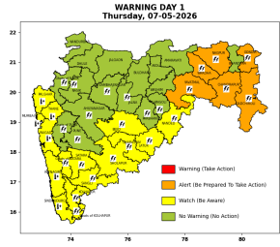 | 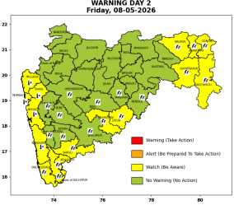 | 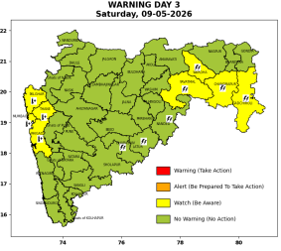 | 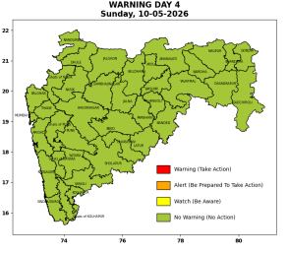 | 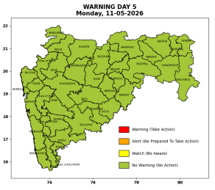

Pune, Lohegaon and Pashan observations at 0830 hrs. IST of Today
 | Temperature (°C) |  |  |  |  | Humidity (%) |  |  |  | Rainfall (mm)
 | Max.  past  24 hrs | Dep.  from  normal | Min.  past  24 hrs. | Dep.  from  normal | Dry  Bulb | At 0830 hrs. IST | Dep.  From  normal | At 1730  hrs. IST of y’day | Dep.  from  normal | Past  24 hrs. | Since  1st March | Dep.  from  normal
PNE | 39.2 | 1.2 | 22.4 | -0.2 | 29.2 | 60 | 4 | 28 | -4 | 0.0 | 92.8 | 74.1
PSN | - | - | - | - | - | - | - | - | - | - | - | -
LHG | 40.2 | 2.2 | 25.8 | 4.8 | 31.1 | 54 | -1 | 15 | -15 | 0.0 | 91.4 | 68.1

 |  |  |  |  |  |  | Local (Pune and neighbourhood) forecast
Max./Min. Temperature (°C) |  |  |  |  |  |  |  |  | Weather
Date | Pune | Pashan | Lohegaon | Chinchwad | Lavale | Magarpatta | NDA | Koregoan park
07/05/26 | 39 / 22.4* | 38 / - | 40 / 25.8* | 39 / 24.8* | 37 / 22.5* | 39 / 26.8* | 37 / 21.2* | 40 / 25.9* | Mainly clear sky becoming partly cloudy sky towards afternoon / evening.
08/05/26 | 40 / 23 | 39 / 23 | 41 / 26 | 40 / 25 | 38 / 23 | 40 / 27 | 38 / 22 | 40 / 26 | Mainly clear sky
09/05/26 | 40 / 23 | 39 / 23 | 41 / 26 | 40 / 25 | 38 / 23 | 40 / 27 | 38 / 22 | 40 / 26 | Mainly clear sky
10/05/26 | 39 / 23 | 38 / 23 | 40 / 26 | 39 / 25 | 37 / 23 | 39 / 27 | 37 / 22 | 39 / 26 | Mainly clear sky
11/05/26 | 39 / 24 | 38 / 24 | 40 / 27 | 39 / 26 | 37 / 24 | 39 / 28 | 37 / 23 | 39 / 27 | Mainly clear sky
12/05/26 | 39 / 24 | 38 / 24 | 40 / 27 | 39 / 26 | 37 / 24 | 39 / 28 | 37 / 23 | 39 / 27 | Mainly clear sky
13/05/26 | 39 / 24 | 38 / 24 | 40 / 27 | 39 / 26 | 37 / 24 | 39 / 28 | 37 / 23 | 39 / 27 | Mainly clear sky
Rainfall Distribution |  |  |  |  | Rainfall Categories | Rainfall (mm) | Cloud condition |  | Rainfall Intensity | Range
Widespread (W) | 76-100% |  |  |  | Very Light rain | Trace to 2.4 mm | Mainly clear sky | 1-2 oktas | Light Spell | 1 cm/hr
 |  |  |  |  | Light rain | 2.5 to 15.5 mm | Partly cloudy sky | 3-4 oktas | Moderate Spell | 1-2 cm/hr
Fairly Widespread (FW) | 51 – 75% |  |  |  | Moderate rain | 15.6 to 64.4 mm | Generally cloudy sky | 5-7 oktas | Intense Spell | 2-3 cm/hr
Scattered (S) | 26 – 50% |  |  |  | Heavy rain | 64.5 to 115.5 mm | Overcast | 8 oktas | Very Intense Spell | 3-5 cm/hr
Isolated (I) | 1 – 25% |  |  |  | Very heavy rain | 115.6 to 204.4 mm |  |  | Extremely Intense Spell | 5-10 cm/hr
Dry (D) | No Rain |  |  |  | Extremely heavy rain | ≥ 204.5 mm |  |  | Cloudburst | > 10 cm/hr
Probability Terms in %: |  |  |  |  | Heavy snow | 6.5 to 11.5 cms water equivalent of rain
unlikely | < 25 |  |  |  | Very heavy snow | 11.6 to 20.4 cms water equivalent of rain
likely | between 25 50
very likely | between 51 75
most likely | >75
* = realized temperatu
Mumbai (Colaba) |  |  |  | Nagpur (AP)
Date 2026 | T max °C | T min °C | Weather | T max °C | T min °C | Weather
07/05/26 | 34 | 28 | Partly cloudy sky. | 43 | 25 | Thunderstorm. Thundersquall with wind speed reaching(50-60kmph)
08/05/26 | 34 | 28 | Mainly clear sky. | 44 | 26 | Thunderstorm. Thundersquall with wind speed reaching(50-60kmph)
09/05/26 | 35 | 29 | Mainly clear sky. | 44 | 26 | Partly cloudy sky.
10/05/26 | 34 | 29 | Mainly clear sky. | 43 | 26 | Mainly clear sky.
11/05/26 | 34 | 29 | Mainly clear sky. | 44 | 26 | Mainly clear sky.
12/05/26 | 34 | 28 | Mainly clear sky. | 44 | 26 | Mainly clear sky.
13/05/26 | 34 | 28 | Mainly clear sky. | 44 | 25 | Partly cloudy sky.

